Note: Take screenshots of the objects you modelled and save them in your documentation.

**Task 1:**

**Doors/Windows**

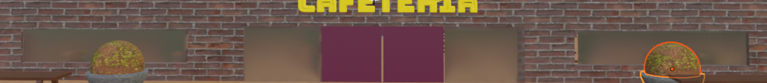

**Interior Lamp**

**Bar Stools**

**Plant Pot**

**Picnic Benches**

**Bar & Shelving**

**2 different bottle models and 1 glass model for bar**

**Lamp Posts**

**Skateboard**

**Wooden Fence**

**Tree Pit Surrounds**

**Gazebo**

**Bridges**

**Benches**

**Cafeteria Name**

**Task 2:**

**1: Walking path:**

**2. Skateboard path:**

**3. Car’s path:**

**Task 3:**

**3. Use UV Editor to map a design on the skateboard’s surface. Provide screenshots from the UV Editor to demonstrate the work done.**

**4. Use UV Editor to map a label on each of the two modelled bottles. Provide screenshots from the UV Editor to demonstrate the work done.**

**Cup 1:**

**Glass Bottle 2:**

